people with cerebral palsy can learn how to operate a motorized wheelchair in a VR environment.5

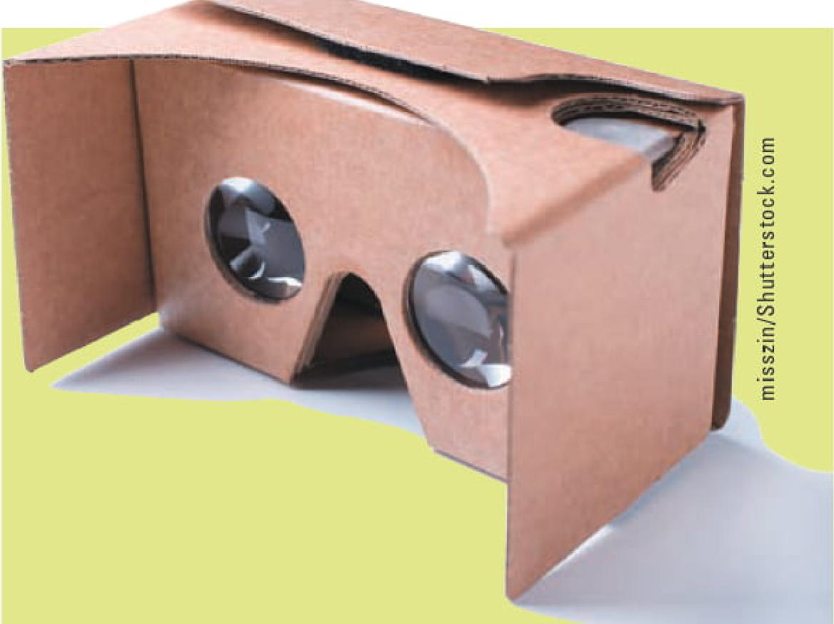

* *Architectural design Architects*and engineers use VR systems to create blueprints and build prototypes to show to clients. With a VR system, several versions of a design can be created to demonstrate to clients the outcome of modifying different factors. Architects and engineers can also use VR systems to safely test different conditions (such as wind shear) without the expense of using physical materials.
* *Education VR*systems are used in educational games and simulations, such as VR "flashcards" for teaching math skills. Incorporating visuals, sound, and touch into a game can help

improve the learning process. For example, in a world geography

class, a VR globe could be used with touch technology that displays different facts about a country—language, population, political system, and so forth—when a student touches it.

* *Flight simulation—*Commercial airlines and the military have been using flight simulators for many years. Flight

simulators are used for training pilots to handle new equipment or unusual operating conditions. Training in a VR environment is safer and less expensive than training on actual equipment.

Google Cardboard is a VR platform developed by Google for use with an HMD and a smartphone app. The user places the smartphone inside the cardboard and views the objects through the HMD. The platform is intended as a low-cost system to encourage interest and develop­ment in VR applications. This $20 device saved the life of a baby who was missing a lung and half a heart by provid­ing images in 3D virtual reality that cannot be seen in a 2D environment. In 2016, doctors at Nicklaus Children's Hospital in Miami used the device to map out an operation that they couldn't have envisioned otherwise. Using the device made it possible to move around and see the heart from different angles—similar to being inside the heart and checking out its structure.6

VR systems can also be used in videoconferencing and group support systems. Current tech­nologies using TV screens cannot fully capture the sense of other people being physically present, and people cannot shake hands or engage in direct eye contact

effectively. VR systems could

**Virtual Reality at Lockheed Martin**

**FINANCE I TECHNOLOGY IN SOCIETY I APPLICATION**

Lockheed Martin Aeronautics Company, with headquarters in Bethesda, Maryland, builds some of the most sophis­ticated military aircraft in the world. A virtual reality and simulation laboratory that the company built in Littleton, Colorado, is used to simulate and test new products and processes before introducing them into the market. The lab can be used for testing space systems, satellites, launch vehicles, and missile defense systems. According to Lockheed Martin, the virtual reality technology brings production costs down by making models of products and testing them before physically manufacturing them. Naturally, modifications on a model are a lot simpler and cheaper than modifying an actual product. One of the lab's first products in which VR was used was the Air Force's GPS III system (a $1.46-billion project), also referred to as *next-generation GPS.* According to the company, the lab may also be used for NASA's Orion project, a space vehicle that will take astronauts to the International Space Station and beyond. Lockheed Martin spokesman Michael Friedman says that the principle behind using virtual reality technology is that"it is easier to move electrons than it is to move molecules"7

**Questions and Discussions**

1. How did virtual reality reduce production costs at Lockheed Martin?
2. What are additional applications of VR technology?

354 PARTTHREE: IS Development, Enterprise Systems, MSS, and Emerging Trends

Copyright 2021 Cerigage Learning. All Rights Reserved. May not be copied, scanned, or duplicated, in whole or in part Due to electronic right, some third party content may bc suppressed from the elliook andlor eChapterfs).
  
Editorial review has deemed that any suppressed content does not materially affect the overall learning experience. Cengage Learning reserves the right to remove additional content at any time if subsequent rights restrictions require it.